Existing Logo: This was created this one for me in October 2013
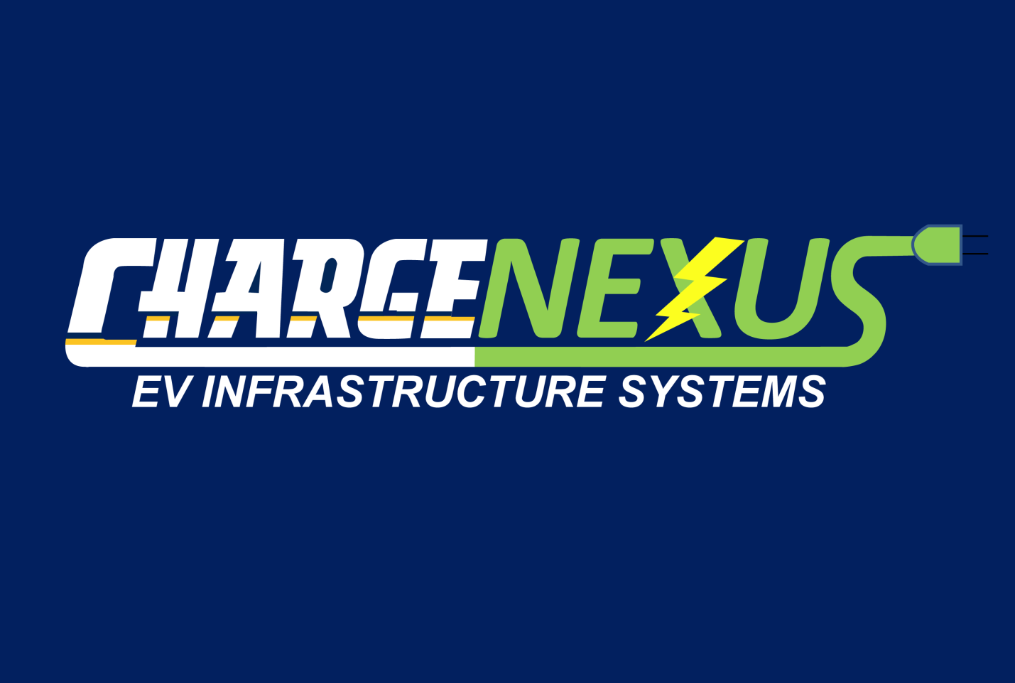

New Logo: Remove yellow and blue line from CHARGE. Leave font the same for “C”. Change font for HARGE to “Impact” or similar. Letter spacing similar to existing.
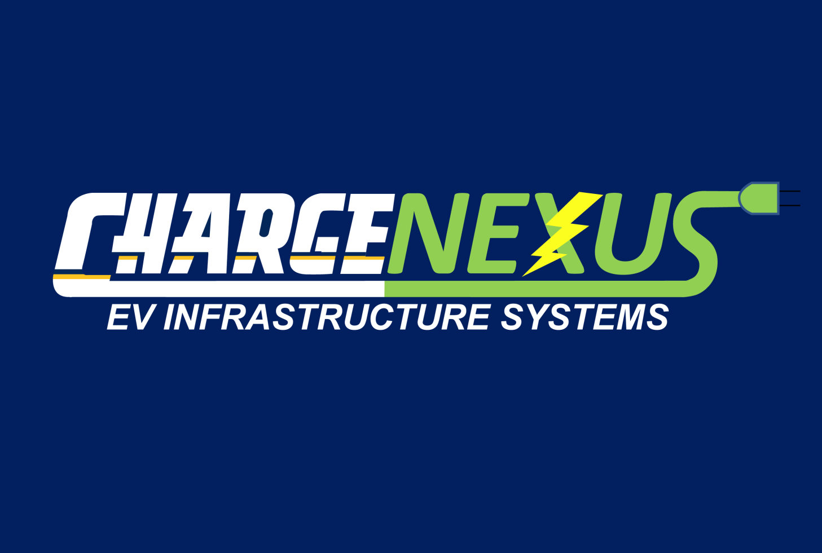
HARGE

This is Impact, Bold, Italic, 60 pt:
HARGE

Logo 1: This revision
Logo 2: Logo 1 with transparent background
Logo 3: Logo 1 with white and blue reversed on transparent background.

